In this lab assignment, we have trained the data using sensor. we took values for 3 movements of the sensor. They are left to right, right to left and punch. These values are trained and then tested using the give URL's in the blaclboard.

left to right

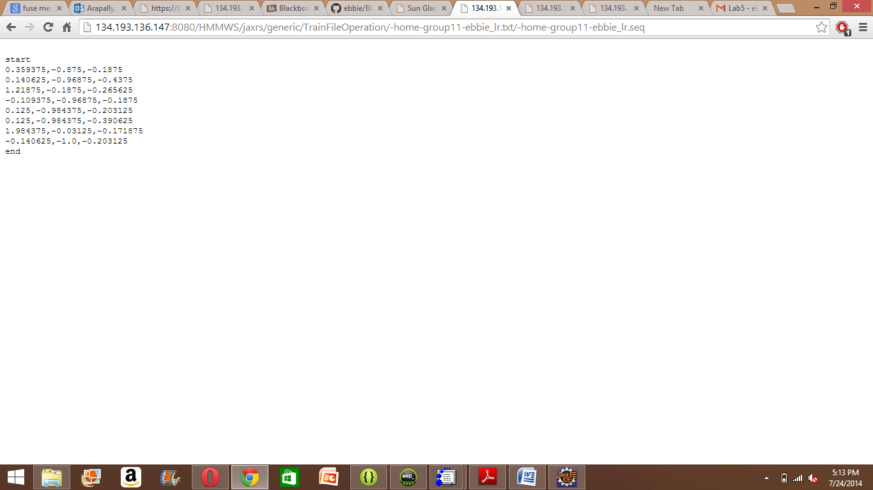

right to left

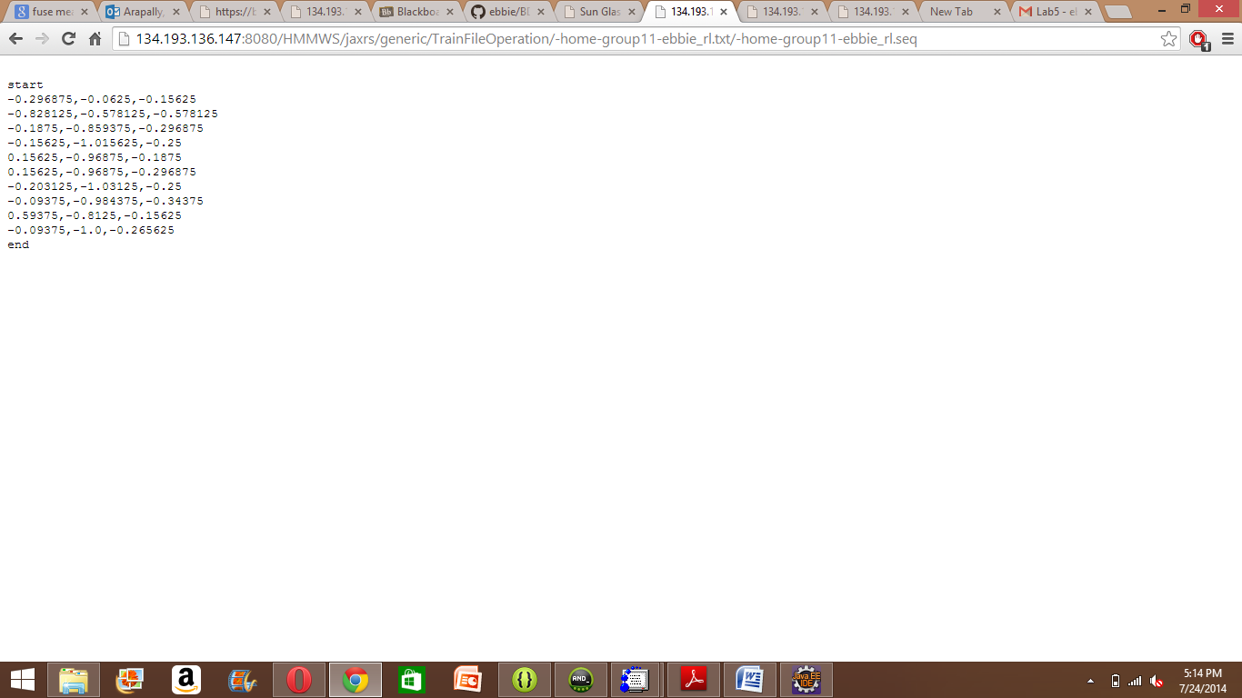

punch train

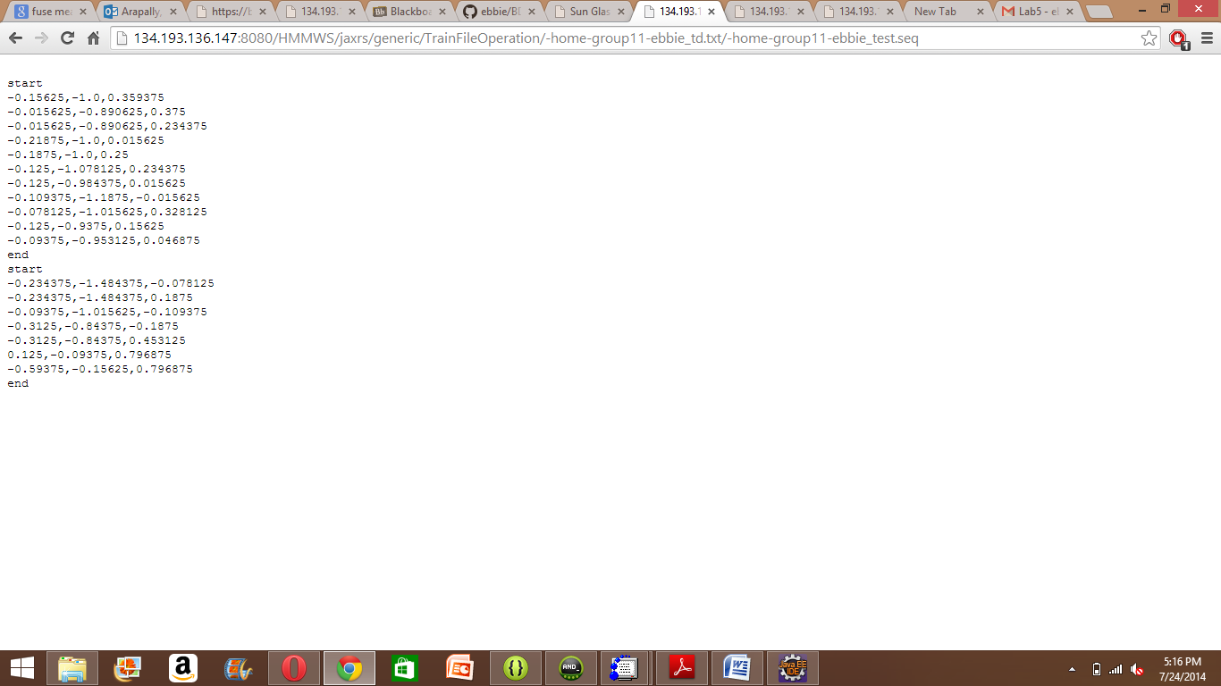

Testing data

